Mantid
Open Source Governance Model Proposal

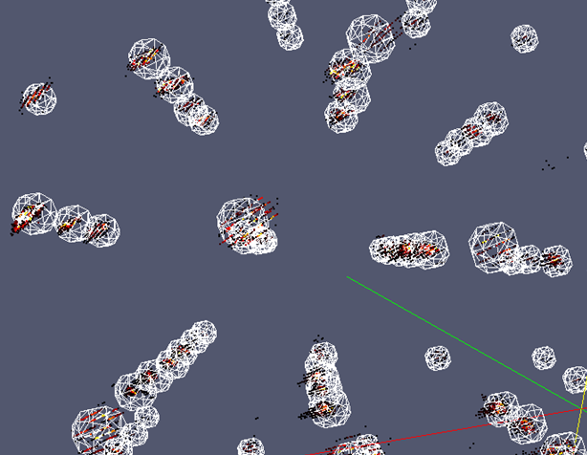
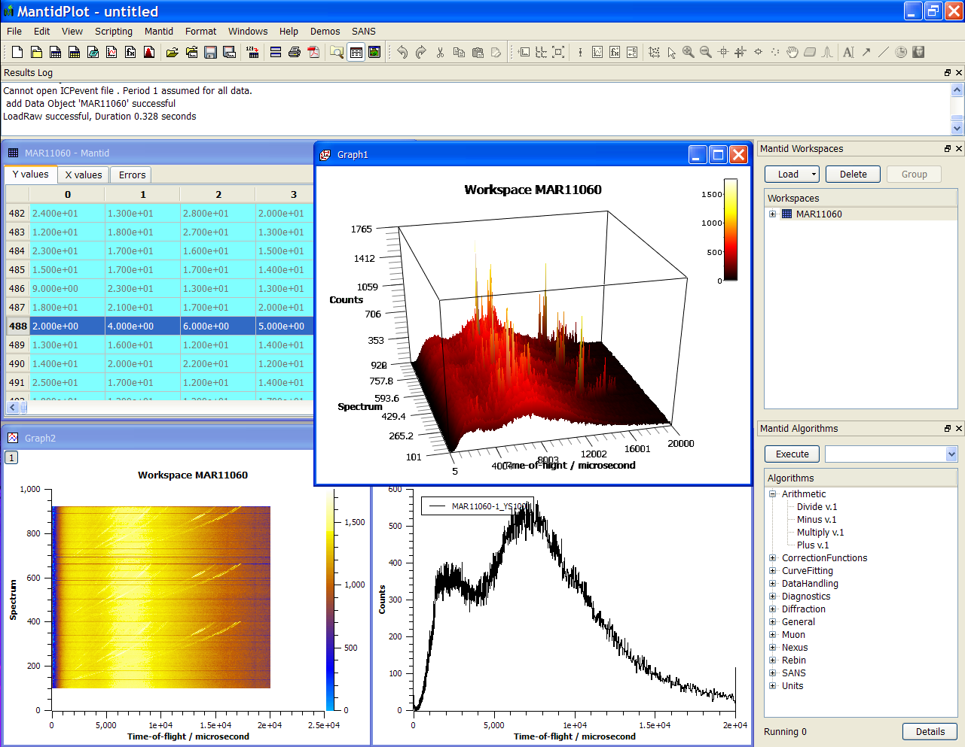

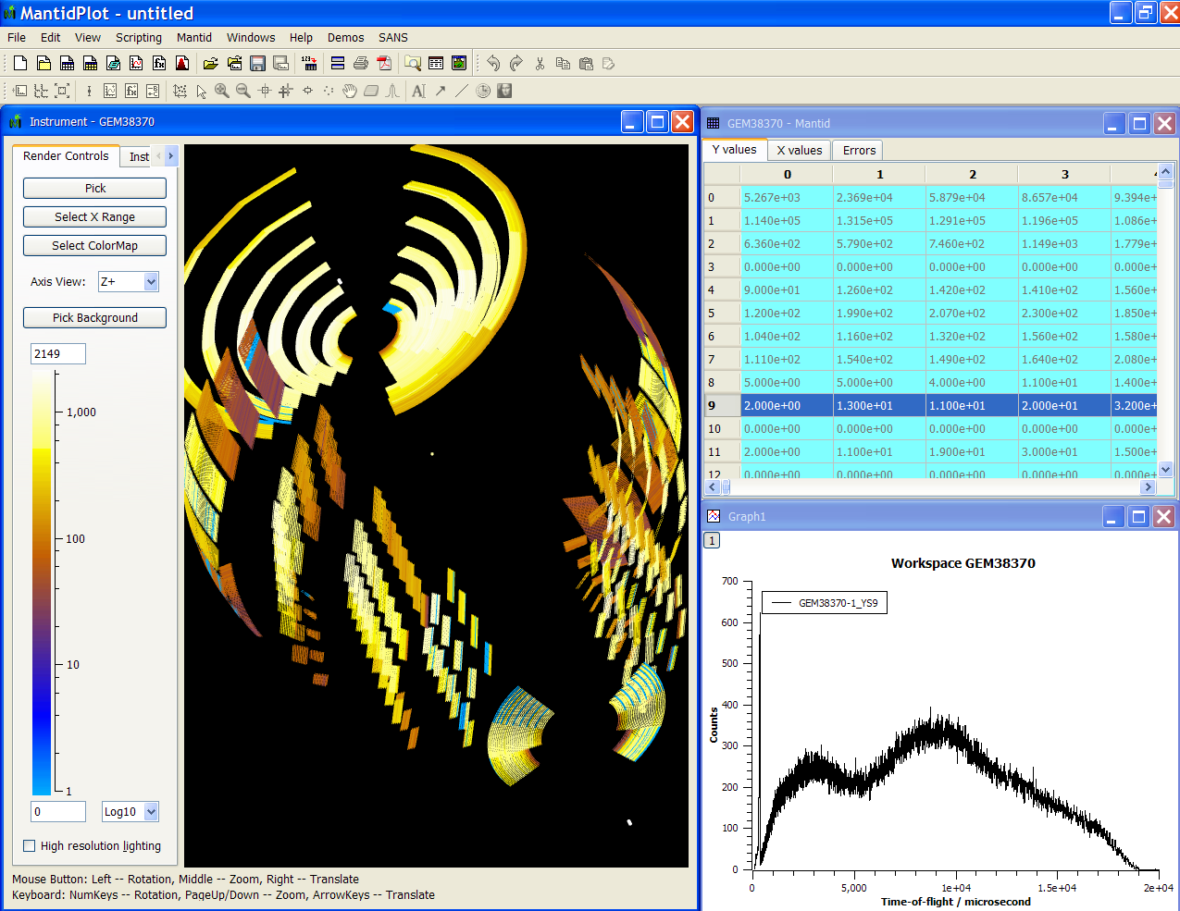
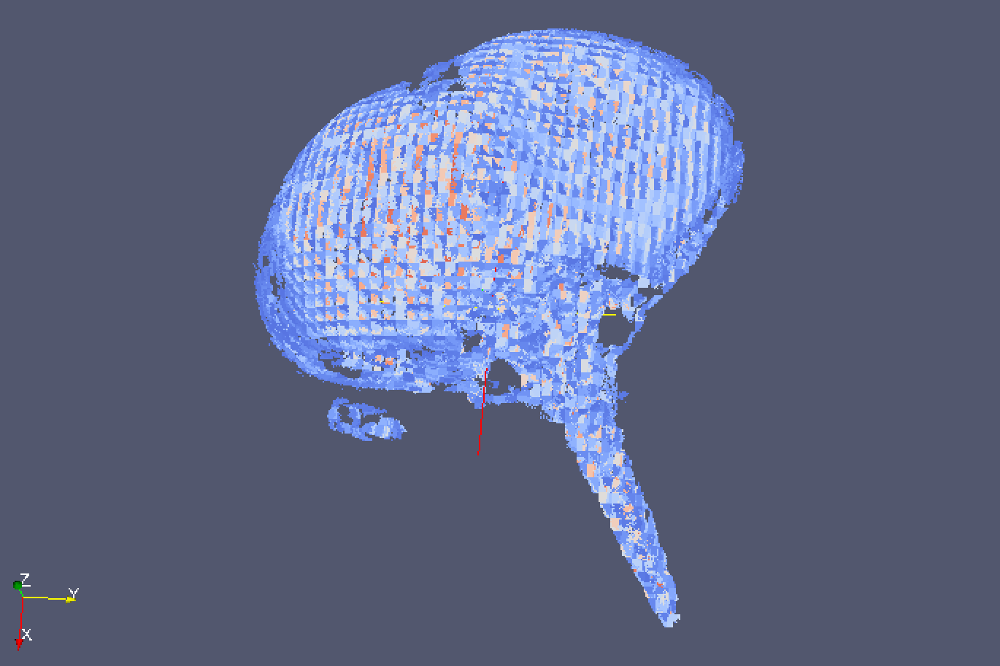
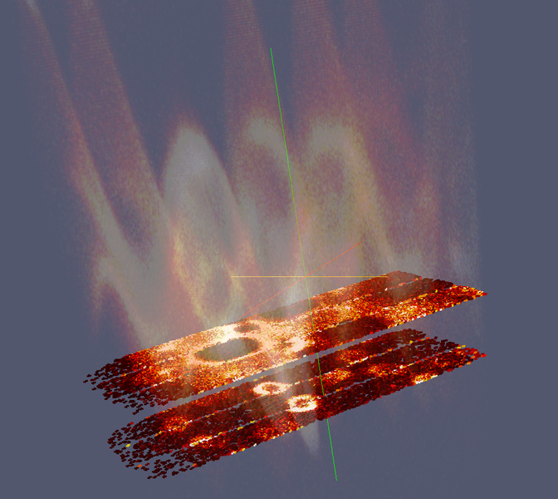
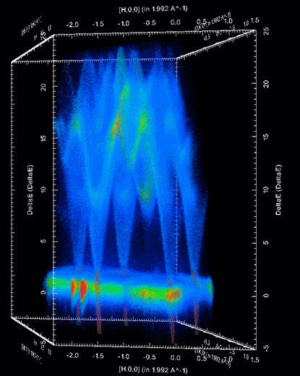
Document Control
This document is under document control. All members of the distribution list will receive updated copies whenever alterations are made. All other copies are uncontrolled.

Contributors
Name | Role | Company
Nicholas Draper | Author | Tessella

Document Approval
Name | Role | Company

Distribution
Name | Role | Company
Project Management Board Members | Recipient | STFC & ORNL
Mantid Project Repository | Filing | STFC & ORNL

Revision History
Author | Issue | Date | Description
Nicholas Draper | V1.R1.M0 | 26-Sep-2013 | 1st version written

References
Document | Ref | Date | Details and Version
Report on Open Source Governance Models | [OSGM] | 11-Jan-2013 | https://github.com/mantidproject/documents/blob/master/Project%20Management/PMB/Report%20on%20Open%20Source%20Governance%20Models.doc?raw=true
Memorandum of understanding between ISIS and NScD | [MOU] |  | http://github.com/mantidproject/documents/blob/master/Project%20Management/Collaborations/ORNL/Appendix%201%20to%20MOU-UTB-2006223%20-%20Rev2.docx?raw=true

Table of Contents
1 Introduction 3
1.1 Purpose of this Document 3
1.2 Scope of this Document 3
1.3 Context of this Issue 3
2 Lessons from the Mantid project 4
3 Proposed governance model for open source scattering software 4
3.1 Governing body structure 4
3.2 Membership agreements 5
3.3 Members and Contributors 6
4 Initial creation to support the Mantid project 6
4.1 Association Membership Terms 6
4.2 Mantid Project Membership Terms 7

Introduction

Purpose of this Document
This document proposes a model for the future governance of open source collaborative software development between large scale scientific facilities. One project that would use this governance structure would be the Mantid project, but it would be available to support other projects as well.
The previous Mantid governance approach would struggle to expand beyond the two initial facilities, as detailed in the Report on open Source Governance Models [OSGM]. This proposed approach should be scalable both for Mantid, but also to host additional projects as well.

Scope of this Document
The scope of this document is to propose a governance structure for the future collaborative software projects including the Mantid project.

Context of this Issue
This is the first draft of this report for initial consideration by project management board members. It will be used as a basis for discussion at the next Mantid PMB meeting. After consideration at the PMB meeting it will be sent as a proposal to the facility directors of ISIS and the NScD for consideration. If approved this will form the basis of the governance structure for the collaborative software projects between the facilities involved.

Lessons from the Mantid project
Through the initial collaboration of ISIS and ORNL on the Mantid project several aspects of the collaboration we identified as being important in the success of a software collaboration agreement. This proposal is an attempt to capture and these aspects in a governance model that will scale across more partners, but also allow this model to be reused for other collaborative projects. Those aspects of the early Mantid collaboration that were viewed as important were:
- The software should be developed as a single software package. Specifically, facility specific versions will not be released.
- The software will be developed and released under an open source license
- Copyright will be jointly held by all participating facilities
- The project management structure, specifically:
  - The Project Management Board, with annual rotation of the chairman position
  - Leadership of the project through a single project manager
  - Agreed standards for testing, documentation and an agreement on maintenance of standards.
- Each member should allocate a level of resources commensurate with their expected level of deployment and development.
- Each member will plan to support their users locally.
- A consistent method for citing the software should be used by all members.
- Each member agrees to treat information from other facilities as confidential.

Proposed governance model for open source scattering software
The open source scattering software association would be a voluntary association made up of its members, for the development support and promotion of the Mantid project, and other collaborative science based software.

Governing body structure
In order to allow the governance structure to be used across several projects we propose that we follow the structure.


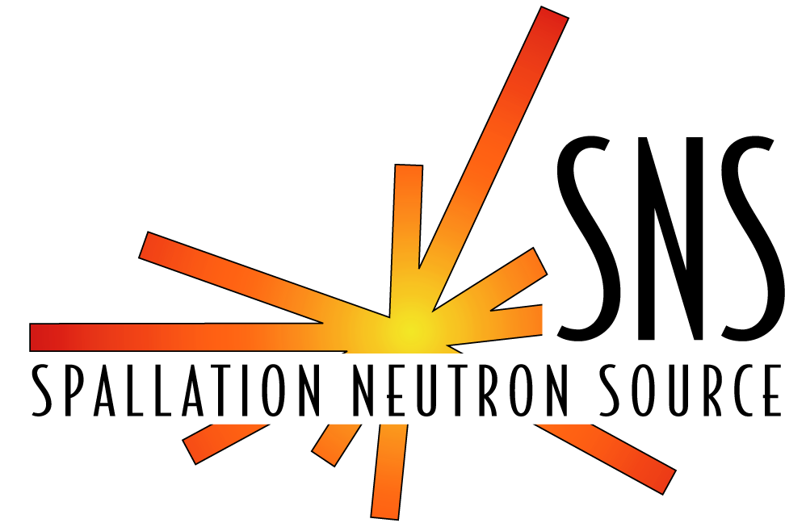

OSSS Governing Board

1 senior member of each contributing facility
Mantid Project

Mantid Project Management Board
Other Project 1

Project Management Board
Other Project 2

Project Management Board

Governing Board
The governing board would comprise one senior member of each contributing facility with the chairperson rotating amongst the members annually. They would provide oversight over all of the projects using the open source scattering software and be a final port of appeal for governance issues that cannot be resolved within the project management boards. They would also be responsible for setting the membership terms for the association, which would apply to all projects within the association.

Project Management Boards
Each project within the OSSS governing body would be overseen by a Project Management Board, which should include the project manager, together with representation senior users and managers from the facilities involved in the collaboration. Chairmanship of the Project Management Board should rotate annually between its members with the restriction that the project manager cannot also be the chairperson of the PMB. The PMB are responsible for:
- Setting the membership terms for the project
- Approving any changes to the membership of the project.
- Championing the project and raising awareness at senior level.
- Approving strategies, implementation plan, project scope and milestones.
- Resolving strategic and policy issues.
- Prioritising project goals with other on-going projects.
- Communicating with other key organisational representatives.

Membership agreements
Each participating member in a project must agree to abide by the membership terms of the association and the project they are joining. This will be recorded by signing a printed copy of the amalgamated membership terms on behalf of the contributing facility to publically acknowledge the commitment of senior management to the project. The agreement will be between the contributing facility and the Open Source Scattering Software Association. As the association itself is not a legal entity these agreements would not be legally enforceable, but would be held as a “Gentleman’s Agreement”.

Copyright
As the association is not itself a legal entity it not be able to hold copyright for any of its projects. Therefore we suggest that all members of each project jointly hold copyright of any creations. This will result in changes to the source code along with changes in the membership of the projects, but this is a fairly easy task to implement.

Joining and leaving a project collaboration
Requests from prospective members who wish to join the project and are willing to abide by the project and association term may be raised at the PMB by any existing member. New members are approved by a majority vote (with the chairperson holding a casting vote in the event of a tie).
The Governing board must be informed for all new membership requests (whether successful or otherwise). A majority vote of the Governing board may overturn the decision of the Project Management Board. This may also be requested by the prospective member as a form of appeal.
Equally if a member of a project is perceived not to be fulfilling their agreement then the Project Management Board may vote to release them from their agreement and the project. A majority vote of all members would be required, and again the Governing Board must be informed and retain the same right to overturn the decision of the Project Management Board. Again, this may be requested as a form of appeal.

Members and Contributors
Projects may well want to collaborate with groups who are not willing or able to abide by the membership agreements. This is fine, for the purposes of this document those parties contributing to the project who have agreed to the membership agreements are referred to as members, and those that have not are referred to as contributors. There rights within the association and projects will be as follows.
 | Contributors | Members
Representation on the Governing Board | No | One seat, shared across all projects
Representation on the Project Managing Board | No | Yes, the number of seats will depend on the project and the level of contribution.
User Support from other members | Good will support only | Best efforts as second line behind local support
Access to the development team | Yes, via defined channels | Unrestricted access
Attend developer meetings | By invitation only | Yes
Able to contribute code, documentation etc | Yes, via the development team | Yes, direct access

Initial creation to support the Mantid project
At the point of creation the OSSS association is likely to initially host the Mantid project alone. Taking this as a starting point I propose the following association and Mantid project membership terms

Association Membership Terms
- The project should be developed as a single software development, separate forks of the software for individual members are not allowed unless explicitly stated in the project terms.
- The code developed on projects as part of this association must be released under an open source license approved by the open source initiative, http://opensource.org/licenses.
- All participants in a project should hold shared copyright over the content of the project.
- The development project should have a proper project management structure:
  - There should be a single overall project manager responsible for delivery of the project. For large projects they may be supported by other project manager or team leads responsible for subsections of the project.
  - A Project Management Board, which should include representatives of all members and the project manager, should meet on a regular basis to review the project status and develop implementation and release strategy, resources required and allocated etc. The chairmanship of the project board should rotate between the participants on an annual basis.
  - There should be agreed standards for development, testing, documentation etc. All participants understand that the maintenance of standards has a very high priority.
- A consistent method for citing the project and deliverables should be used by the Participants.
- Each member acknowledges that any Confidential Information obtained from, or relating to, the any other member is the property of that other and will treat such information as confidential. Confidential information should only be disclosed to a third party with the prior written consent of the other member. Each member may disclose the Confidential Information pursuant to a statutory obligation, an order of a court of competent jurisdiction, or the requirement of a competent regulatory body, provided that it notifies the other member as soon as the requirement to notify arises and will use its reasonable endeavours to minimise the extent of such disclosure and, where possible, to ensure the continued confidentiality of the Confidential Information so disclosed.

Mantid Project Membership Terms
- Mantid is an open source project developed and released under the GNU General Public License as published by the Free Software Foundation; either version 3 of the License, or any later version. (License conditions are available at http://www.gnu.org/licenses/). This supersedes term A2.
- Each member should provide representation to the Mantid Scientific Steering Committee for each of the scientific techniques. The Scientific Steering Committee will meet annually to provide medium and long term direction to the project management board.
- The project working group should meet on a regular basis (weekly) to agree the distribution of work and monitor its progress, within the long term framework set by the project board.
- There will be a single Mantid project manager, though facilities may appoint local managers of their activities which will report to the Mantid project manager.
- Each member should allocate a level of resources commensurate with their expected level of deployment and development of the software. Each member should support the development of the core framework and basic analysis and visualisation capabilities, as well as the scientifically specific parts.
- Each member should in the first instance provide user support locally. This is in any case advisable because each member should have an in-depth knowledge of the software. Best efforts should be made to provide mutual support, especially where local knowledge is lacking. Help desks should be set up for this purpose.
- All development staff will work within the coding, and testing standards and workflow as defined on the Mantid project website http://www.mantidproject.org/Category:Development

